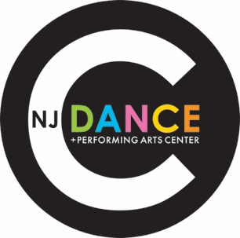
NJCOD Dance Company

2022-23 Conflict Submission Form FormForm

Dancer’s Name: ___________________________________ Today’s Date ________________

Parent’s Name: ___________________________________ Email: ______________________

Team: (Circle One.) Platinum Gold Silver Silver Mini

Date of Conflict: ___________________________

***Please note: Conflicts should be submitted as soon as you are aware of them. All scheduled rehearsals and competitions are mandatory. Conflicts will be accepted for mandatory school events & religion ONLY, and ONLY pertaining to the immediate family or Company member. Any acceptable conflicts must be submitted in writing by filling out a conflict form. Conflicts will not be accepted once a rehearsal schedule is posted and/or a competition schedule is finalized.
Acceptable Conflicts:
Dancer is in a wedding; Dancer’s Communion/Bat Mitzvah; Sibling’s Graduation, etc.

Not Acceptable:
Dancer’s birthday; Friend’s birthday; Friend’s Bar Mitzvah, etc.

Description of Conflict:
__________________________________________________________________________________________________________________________________________________________
_____________________________________________________________________________

We are aware that life happens. In the event that an emergency or last minute conflict should come up please contact your coordinator ASAP. Thank you for your cooperation.
Questions? Contact Erin Florio at njcodcompany@gmail.com.

